|  |  |
| --- | --- |
| September 2024 | School Health Nursing Service  Badger House  Oldmixon Crescent  Weston-Super-Mare  North Somerset  BS24 9AY  Tel: **0300 125 6798**  Email: [nsomerset.schoolnurses@nhs.net](mailto:nsomerset.schoolnurses@nhs.net) |

**September 2024 Intake - Reception Year**

Dear Parent/Guardian,

Starting school can be both an exciting and worrying time for you and child. Your child is taking a big step and starting a new chapter of their life. We would like to take this opportunity to welcome you and your child to the School Nursing Service. The School Nursing Service provides public health services to children 5 -19 years across North Somerset, we will be here to support you and your child as they make their journey through education.

The School Nursing Team is contactable 09:00am -17:00pm Monday – Friday (all year round) on **0300 125 6798** or by emailing: [nsomerset.schoolnurses@nhs.net](mailto:nsomerset.schoolnurses@nhs.net) should you wish to discuss any health concerns you may have about your child.

National Child Measurement Programme (NCMP) and Vision Screening

Every year in England, school children in Reception and Year 6 have their height and weight checked at school as part of the National Child Measurement Programme (NCMP). Height and weight measurements are used to calculate weight status and are shared with parents/carers in the form of a feedback letter. We collect this information to build a picture of how children are growing across the country to help plan better health and leisure services for families.

Alongside measuring height and weight, your child will also be offered a basic vision screen. NHS guidelines recommend that all children’s eyesight is checked in their first year at school with the aim of finding any problems early so that your child can receive effective treatment. If your child is currently wearing glasses, they will not need the check.

After the October half term break you will receive further information electronically via school about the National Child Measurement Programme (NCMP) and the Vision Screen.

All parents/carers will be given the option for your child not to take part in either of the programmes by completing and returning the opt-out forms to the school nursing team by a set date. If you need further support with the electronic form or if it is needed in an alternative format, please do not hesitate to contact the school nursing service.

If you would like to find out how else the School Nursing Service can support you and your child, please access the Sirona website at <https://sirona-cic.org.uk/children-services/> or scan the QR code below.

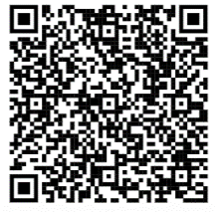

If you have any queries, please do not hesitate to contact us.

Yours faithfully,

School Nursing Team

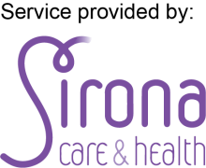Sirona care & health C.I.C is a Community Interest Company registered in England and Wales with company number 07585003. Registered office is Sirona care & health, 2nd Floor, Kingswood Civic Centre, High Street, Kingswood, Bristol, BS15 9TR